NAME: Ch. usha sri

ROLL NO:21481A0223

Data Analytics

Assignment-4

1. Create Calculation Fields:

● Create two calculated fields and use them in any visualization

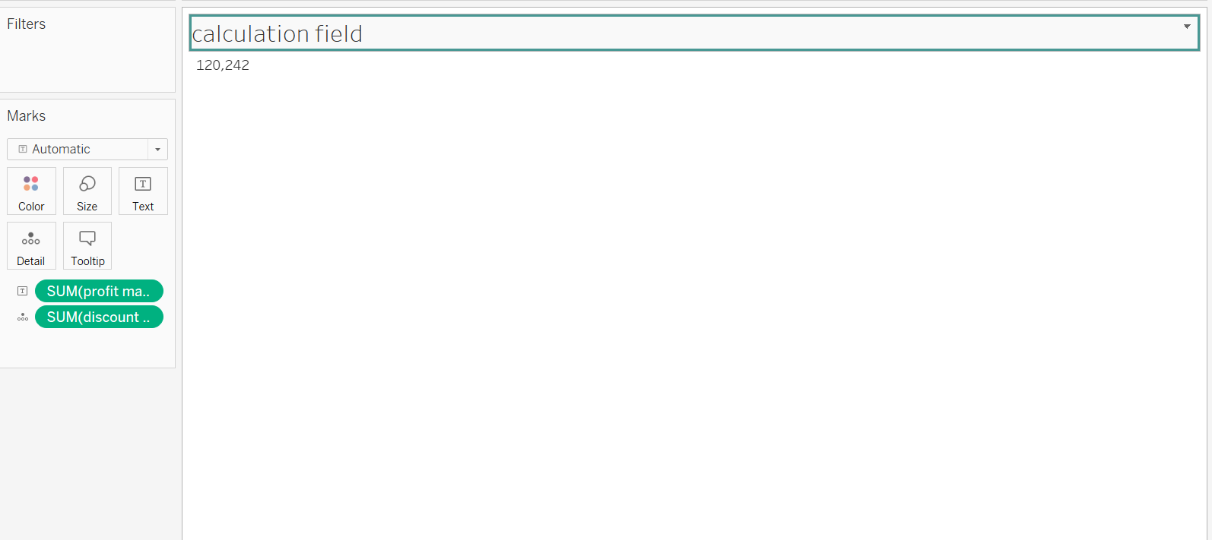

2. Actions

● Implement a highlight action to emphasize specific data points, such as highlighting the sales of bottom-performing products when a particular customer is selected.

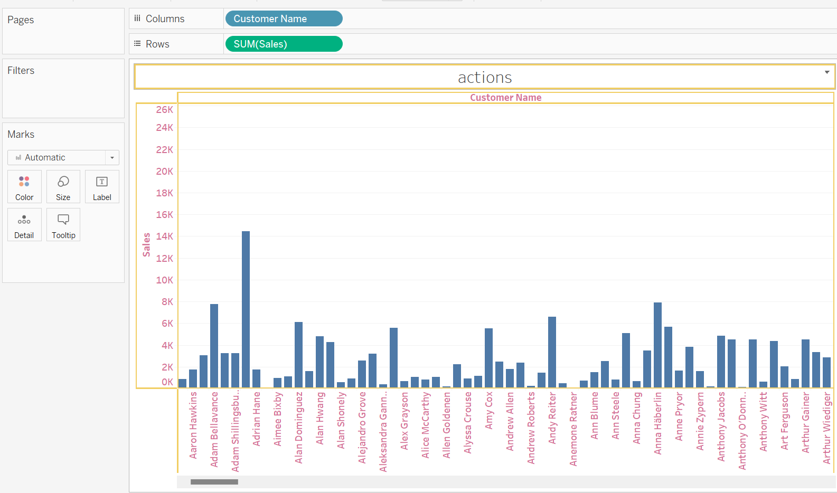

3. Sets

● Define at least two sets based on specific criteria from your dataset (e.g., low-value customers, bottom-performing products).

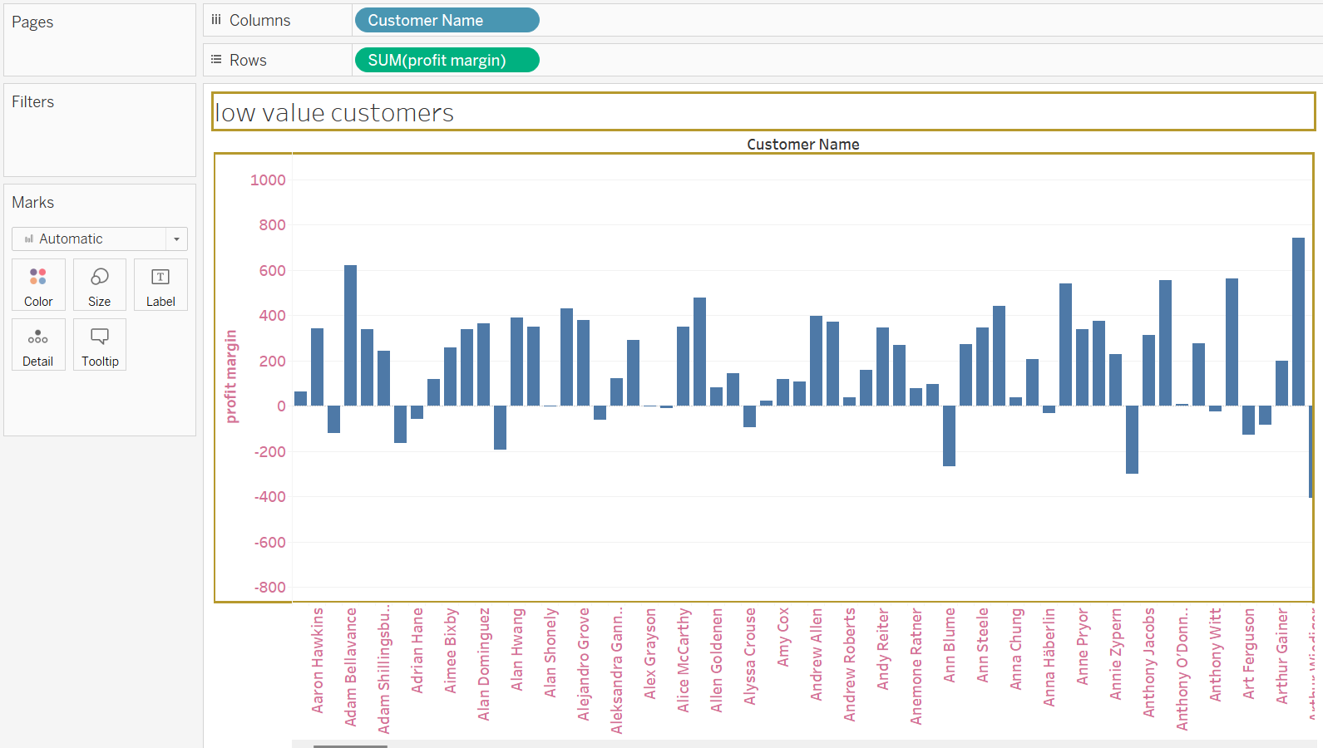

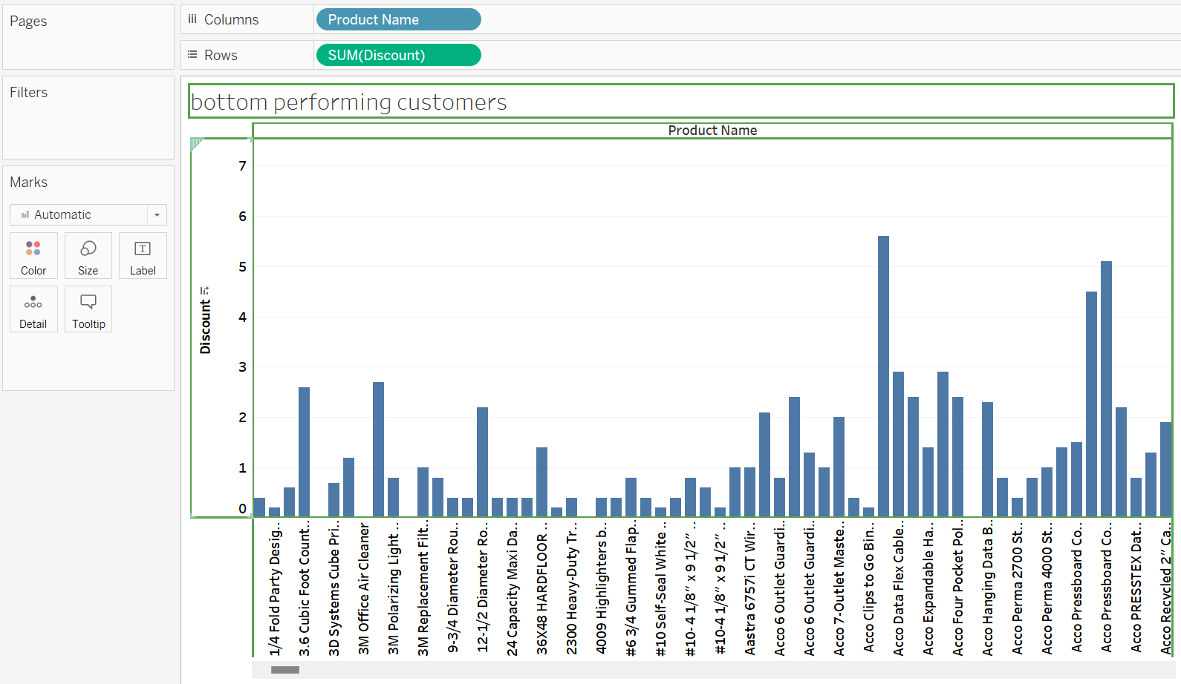

4. Filters

● Use the 6 types of filters and create individual visualizations (each)

